**Biology: 15. Genetics**

***Please remember to photocopy 4 pages onto one sheet by going A3→A4 and using back to back on the photocopier***

**Syllabus**

**OB35** Understand that humans have inheritable and non-inheritable characteristics, and that inheritable characteristics are controlled by genes

**OB36** Recall that genes are located on chromosomes and that in a human there are 23 pairs of chromosomes, which are located in the nucleus

**OB37** Recall that chromosomes are made of DNA and protein.

**Genetics is the study of heredity**

**Student Notes**

**Inherited characteristics such as eye and hair colour are controlled by genes**

**Non-inherited characteristics, such as playing a guitar or riding a bike, must be learned**

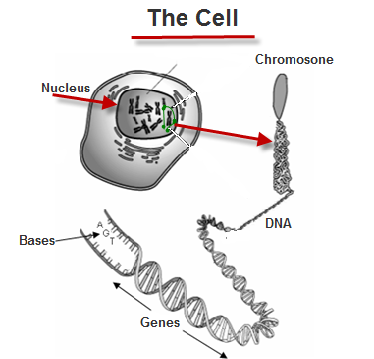

**Chromosomes are located in the nucleus of a cell**

**Chromosomes are made of DNA and protein**

**Each cell nucleus (in humans) contains the same 23 pairs of chromosomes**

**Genes are found on chromosomes**

***Did you know diarrhoea is hereditary?   
Yeah, it runs in your jeans.***

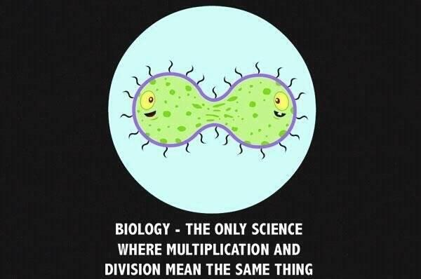

**Exam Questions**

1. [2007]
2. Where is DNA located in cells?
3. Name a second substance associated with DNA.
4. [2010][2012]

Name the two principal substances that chromosomes are composed of.

1. [2008]

At certain stages in the life of a cell thread-like structures that contain genes can be seen in the nucleus.

1. What are these thread-like structures called?
2. Genes are located on these thread-like structures. Give a role that genes play in life processes.
3. [2006]

Eye colour, hair texture and many other human characteristics are controlled by genes.

1. Name the structures in the nuclei of our cells where genes are located.
2. Name the substance that genes are made of.

|  |  |
| --- | --- |
|  | Ability to drive |
|  | Freckled skin |
|  | Tongue rolling |
|  | Ability to knit |

1. [2009 OL][2012 OL]

Inheritable characteristics are controlled by genes.

Write the letter I beside two inheritable characteristics in the table.

**Exam Solutions**

1. In the nucleus.
2. Protein
3. DNA and protein
4. Chromosomes
5. Inheritance/ passing on of characteristics/ produce protein
6. Chromosomes
7. DNA
8. Freckled skin, tongue rolling

**In case you were wondering**

Yeasts are made of just a single cell but we share thousands of similar genes with them, most of which are crucial to the yeast’s survival.

Scientists even managed to remove these genes from the yeast and replaced them with genes from a human cell and the yeast not only survived but were even able to reproduce. So in effect the scientists had created new ‘strains’ of yeast each of which now include a single human gene.

This is because yeast and humans share a common ancestor – so billions of years ago we were one and the same!

That’s mad Ted!

By the way, more ‘advanced’ lie-forms don’t necessarily have more chromosomes; humans have 46 pairs of chromosomes - pineapples have 50.

**Sex and reproduction actually serve two different functions.**

Asexual reproduction is actually much more efficient in propagating a species because all the genes of the parent pass on to the next generation.

So why have sex (apart from the obvious ‘because it’s fun’)?

It turns out that the function of sex is to promote variability by mixing the genes of two individuals. Why do we want variability? – it means that the individuals within a species (e.g. different people within the human race) have different characteristics and this gives them a better chance of adapting to and surviving a changing environment.

Asexual reproduction makes identical copies of parental cells (unless a new mutation occurs during the copying process).

Some species (e.g. many types of insect) reproduce by parthenogenesis (reproduction without fertilisation).

This from Stephen Jay Gould:

Micromalthus debilis, a species of beetle:

Some parthenogenetic females give birth to a single male offspring. This larva attaches to his mother’s cuticle for about four or five days, then inserts his head into her genital aperture and devours her. Greater love hath no woman.

If we were to run the tape of life again, would humans appear – very, very unlikely.

How long have humans been around (relative to the when first life appeared on Earth)?

Did you know that as recently as 50,000 years ago there were four or perhaps five different species of humans alive on Earth? Why did the other species die? Nobody knows for sure.